Global Olympic Sports Performance Analysis
Project Documentation
Project Title | Global Olympic Sports Performance Analysis
Project Member | Self
Date | 28-10-26
Team ID
Maximum Marks
Tool used: Tableau
Table of Contents

If the page numbers above are blank or out of date, right-click the table and choose “Update Field” in Microsoft Word.

About This Document
This report documents the Tableau work completed for the project “Global Olympic Sports Performance Analysis”. It follows the ten-section structure of the supplied reference documentation (Problem Statement, Dataset, Data Preparation, Data Visualizations, Dashboard, Story, Performance Testing, Web Integration, Publishing and Project Links, Conclusion and Learnings).
All descriptions of charts, values and layout are based only on the two Tableau screenshots supplied with the project. Where the screenshots do not show a detail, or where no evidence was supplied (for example, the Tableau Story, performance timings, web integration and publishing links), the report says so and leaves the field open for confirmation instead of guessing. Values that were calculated from numbers visible in the screenshots are marked as “derived”. Statements that are interpretations rather than visible facts are marked as such.

1. Problem Statement

1.1 Introduction and Background
The Olympic Games bring together athletes from many countries in Summer and Winter editions. Records of these Games contain information about each athlete, such as sex, age, height, weight, country, sport, year, season and medal won. Stored as rows in a CSV file, this information is difficult to read and compare. Data visualisation in Tableau allows such records to be summarised in charts so that patterns become visible at a glance.
This project uses a data file named athlete_events.csv and builds nine Tableau views that describe participation and medals. The Athletes Over Years chart spans an axis from about 1900 to about 2020, so the analysis covers more than a century of Olympic history.

1.2 Problem Statement
Row-level Olympic records do not directly show how athlete participation has changed over time, which sports attract the most athletes, how participation differs between women and men and between Summer and Winter Games, what typical athlete ages are, or which countries and athletes have won the most medals. This project converts the records into a set of Tableau visualisations and a dashboard so that these questions can be answered visually.

1.3 Objectives
- Load the athlete_events.csv data into Tableau and prepare the fields needed for analysis.
- Build visualisations of athlete participation by year, sex, season, sport and age, and of athlete height and weight.
- Build visualisations of medals by country (NOC), of the distribution of medals among athletes, and of individual athletes.
- Combine the visualisations into a Tableau dashboard that presents the findings on a single page.
- Present the key observations in a Tableau Story. (No Story evidence was supplied; see Section 6.)

1.4 Scope of the Project
Within scope (supported by the screenshots): descriptive visual analysis using nine Tableau views and a dashboard built from athlete_events.csv, covering participation, demographics (sex and age), body measurements, sport, season, medals by country and medal counts by athlete.
Not claimed in this report (no supporting evidence supplied): predictive modelling, statistical testing, multi-file data modelling, web integration, and measured performance results.

1.5 Intended Users and Their Needs
The user needs below are assumptions drawn from the content of the visualisations. No user research, interviews, empathy map or brainstorming records were supplied, so none are reported here.
- Students and analysts who want a quick overview of Olympic participation and medals.
- General readers who want to compare sports, countries and seasons without reading raw data.
- Reviewers who need clear titles, legends and value labels to interpret each chart.

2. Dataset
The data comes from a single file, athlete_events.csv. The file name is visible in the axis title “Count of athlete_events.csv” in the Medals by Country chart (Figure 7). The number of rows and columns, the original source of the file and the date of download are not visible in the screenshots and are therefore left for the author to confirm.
Three types of measure appear in the visualisations. Distinct count of ID counts each unique athlete identifier once within each category shown. Count of athlete_events.csv counts the records (rows) of the file. Count of Medal and Count of ID count medal entries and identifiers respectively for the athletes shown.
Table 1: Data fields evidenced in the screenshots
Field | Evidence in the screenshots | Used in
ID | Athlete identifier; numeric values such as 94406 and 67046 appear as row labels | Participation charts (Distinct count of ID); Medal Distribution; Top 10 Athletes
Name | Athlete names such as “A. Albert” and “A. Dubois” | Top 10 Athletes
Sex | Values F and M | Gender Participation
Age | Grouped into bins (axis title “Age (bin)”, axis labels from 15 to 95) | Age Distribution
Height | Numeric values on the column axis (for example 127 to 133) | Height vs Weight
Weight | Numeric values on the row axis (for example 41 to 43) | Height vs Weight
NOC | Country codes such as USA, URS, GER, GBR, FRA, ITA, SWE, CAN, AUS, RUS | Medals by Country
Year | Axis from about 1900 to about 2020 | Athletes Over Years
Season | Values Summer and Winter | Athletes Over Years; Summer vs Winter
Sport | Long list of sports in the legend, for example Aeronautics, Alpine Skiing, Athletics, Swimming, Luge | Sports Participation (colour legend)
Medal | Values Bronze, Gold and Silver | Medals by Country; Medal Distribution

Aggregate values visible in the screenshots. The Gender Participation chart shows 33,981 female and 1,01,590 male athletes (distinct count of ID). The numbers are displayed with Indian digit grouping, so 1,01,590 equals 101,590. Together the two bars represent 135,571 distinct athlete identifiers (derived). The Summer vs Winter chart shows 1,16,776 (116,776) for Summer and 18,958 for Winter.
Placeholder: a screenshot of the Tableau Data Source page was not supplied. It can be inserted here if the template requires it.

3. Data Preparation
The following preparation steps are supported by what is visible in the screenshots.
- The file athlete_events.csv was used as the data source for all views (shown by the measure name “Count of athlete_events.csv”).
- Athlete participation was measured with Distinct count of ID, so that each athlete identifier is counted once within each category displayed.
- The Age field was grouped into bins to create the Age (bin) axis used in the Age Distribution chart.
- The Medal field shows only three values (Bronze, Gold, Silver) in the legends. No blank or “Null” category is displayed, which suggests that records without a medal were excluded from the medal views. The method used (filter or other setting) is not visible and should be confirmed.
- The Sports Participation, Medals by Country and Medal Distribution charts are ordered from the largest to the smallest value, and sort indicator icons are visible next to the field names Sport, NOC, ID and the measure titles.
- Colour legends were configured for Season (Summer, Winter), Sex (F, M), Medal (Bronze, Gold, Silver) and Sport.
Not evidenced and therefore not described: whether the data was connected live or as an extract, any joins or relationships, calculated fields, filters applied to the data source, and the treatment of missing values in Age, Height and Weight. These details can be added by the author.

4. Data Visualizations
Nine views were identified in the screenshots. The Dashboard pane in the second screenshot lists nine worksheets with the default names Sheet 1 to Sheet 9, whereas the visible chart titles are descriptive. Because the screenshot does not show which sheet number corresponds to which chart title, the views below are identified by their visible titles.
Table 2: Summary of the nine views
View | Chart type | Fields used (as visible) | Purpose
Athletes Over Years | Line chart | Year (x-axis), Distinct count of ID (y-axis), Season (colour) | Shows how the number of athletes changed over time for Summer and Winter
Gender Participation | Bar chart | Sex, Distinct count of ID | Compares the number of female and male athletes
Height vs Weight | Scatter plot | Height (columns), Weight (rows) | Shows how athlete height and weight are related
Sports Participation | Horizontal bar chart | Sport, Distinct count of ID, Sport (colour) | Ranks sports by number of athletes
Summer vs Winter | Bar chart | Season, Distinct count of ID | Compares athlete numbers in the two seasons
Age Distribution | Column chart of binned ages (histogram style) | Age (bin), Distinct count of ID | Shows how athletes are spread across ages
Medals by Country | Stacked horizontal bar chart | NOC, Count of athlete_events.csv, Medal (colour) | Compares medal totals of leading countries by medal type
Medal Distribution | Stacked horizontal bar chart | ID, Count of Medal, Medal (colour) | Shows how many medals individual athletes hold, by medal type
Top 10 Athletes | Horizontal bar chart | Name, Count of ID | Intended to list leading athletes by count

4.1 Athletes Over Years
This line chart plots Year on the horizontal axis (labelled from 1900 to 2020) and Distinct count of ID on the vertical axis (labelled 5K and 10K). Two lines are drawn, coloured by Season: Summer in blue and Winter in orange. Each point shows the number of unique athletes recorded for that year and season.
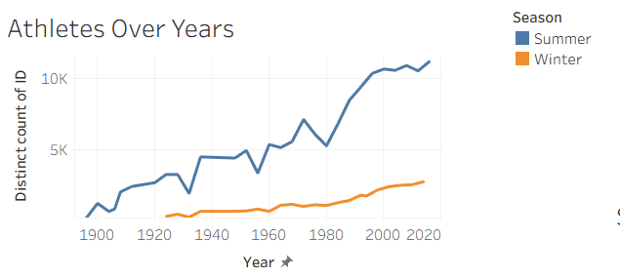
Figure 1: Athletes Over Years: distinct athletes per year, by season
How to read it: follow each line from left to right to see growth or decline; compare the heights of the two lines to compare seasons.
Observations (read from the axes, approximate): the Summer line begins close to the 1900 mark, rises with several visible dips and recoveries, and ends just above 10K near the right end of the axis. The Winter line starts later, in the 1920s, stays below the Summer line throughout, and ends at a few thousand athletes.

4.2 Gender Participation
This bar chart compares the two values of Sex (F and M) using Distinct count of ID. Value labels are shown on the bars, and the legend colours female athletes blue and male athletes orange.
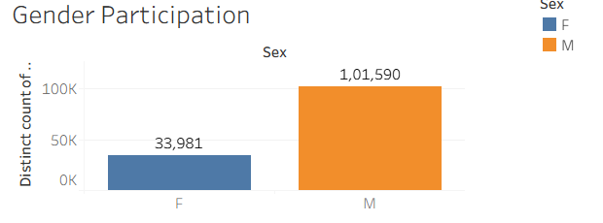
Figure 2: Gender Participation: distinct athletes by sex
Observations: 33,981 female athletes and 101,590 male athletes are shown. From these values, females make up about 25.1% and males about 74.9% of the 135,571 athletes represented (derived). Male athletes are roughly three times as numerous as female athletes in this dataset.

4.3 Height vs Weight
This scatter plot places Height on the column axis and Weight on the row axis, so each mark represents a combination of the two measures. The measurement units are not shown in the screenshot.
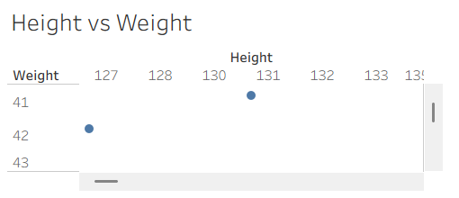
Figure 3: Height vs Weight: scatter plot (partial view)
Limitation: only a small portion of the chart is visible in the screenshot (height values from about 127 to 133 and weight values from 41 to 43, with two marks and scroll bars). The overall relationship between height and weight therefore cannot be described from the evidence supplied. A screenshot of the whole chart is recommended.

4.4 Sports Participation
This horizontal bar chart lists sports on the vertical axis and Distinct count of ID on the horizontal axis (0K to 25K). Bars are sorted from largest to smallest and coloured by Sport. A scroll bar indicates that more sports lie below the visible portion.
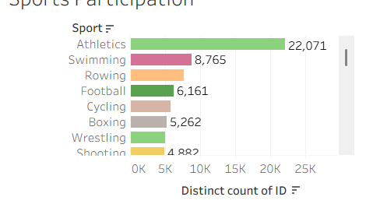
Figure 4: Sports Participation: distinct athletes per sport
Observations: the visible order of sports is Athletics, Swimming, Rowing, Football, Cycling, Boxing, Wrestling and Shooting. Value labels are visible for Athletics (22,071), Swimming (8,765), Football (6,161), Boxing (5,262) and Shooting (4,882, partly cut off). The labels for Rowing, Cycling and Wrestling are not visible. Athletics has roughly two and a half times as many athletes as Swimming (derived).

4.5 Summer vs Winter
This bar chart compares the two Season values using Distinct count of ID.
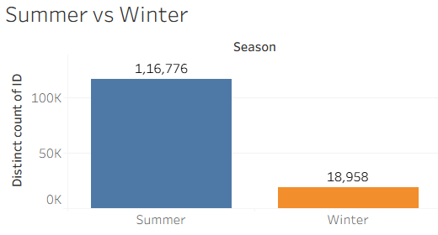
Figure 5: Summer vs Winter: distinct athletes by season
Observations: Summer shows 116,776 athletes and Winter shows 18,958. Summer therefore accounts for about 86% of the combined total and Winter about 14% (derived), a ratio of roughly six to one.

4.6 Age Distribution
This column chart shows Age (bin) on the horizontal axis (labelled from 15 to 95) and Distinct count of ID on the vertical axis (up to 60K and above). It works like a histogram: each column is the number of athletes in one age band.
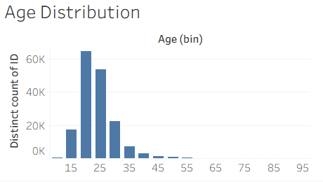
Figure 6: Age Distribution: distinct athletes by age bin
Observations (read from the axes, approximate): the tallest columns lie between ages of about 20 and 30, with the highest just above 60K. The columns fall sharply after about 35 and become very small beyond about 55. The bin width is not stated; the column spacing suggests bands of about five years (interpretation).

4.7 Medals by Country
This stacked horizontal bar chart shows ten countries identified by NOC code, in the order USA, URS, GER, GBR, FRA, ITA, SWE, CAN, AUS and RUS. The horizontal axis is Count of athlete_events.csv (0K to above 5K). Each bar is divided by Medal. According to the legend, Bronze is blue, Gold is orange and Silver is red, and the segments are stacked in the order silver, gold, bronze from left to right. These colours differ from the usual gold, silver and bronze convention, so the legend must be consulted.
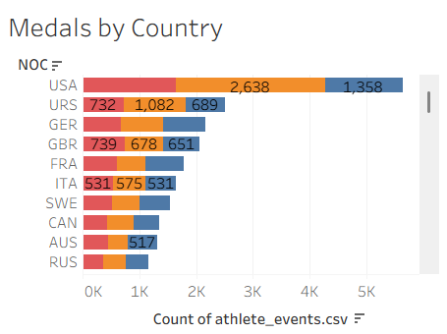
Figure 7: Medals by Country: medal records for leading NOC codes
Visible value labels: USA – 2,638 (gold segment) and 1,358 (bronze segment); URS – 732 (silver), 1,082 (gold) and 689 (bronze); GBR – 739 (silver), 678 (gold) and 651 (bronze); ITA – 531 (silver), 575 (gold) and 531 (bronze); AUS – 517 (bronze). The remaining segments are not labelled.
Observations: USA has the longest bar, followed in order by URS, GER and GBR, so the chart is sorted by total. The codes follow standard Olympic committee abbreviations (for example, URS is the code commonly used for the former Soviet Union); country names are not displayed. Because the measure counts records of the file, the figures represent medal records and should not be read as medal-table totals unless the author confirms how team medals are recorded.

4.8 Medal Distribution
This stacked horizontal bar chart lists athlete identifiers (ID) on the vertical axis and Count of Medal on the horizontal axis (0 to 30), with segments coloured by Medal. The rows are sorted from the highest to the lowest total.
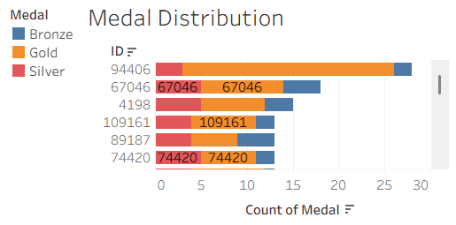
Figure 8: Medal Distribution: medals held by individual athlete IDs
Observations (read from the axis, approximate): the first athlete ID shown, 94406, has the longest bar, reaching about 28 medals, with most of the bar in orange (Gold). The other visible IDs (67046, 4198, 109161, 89187 and 74420) have bars of roughly 13 to 18 medals.
Limitation: some segments display the athlete ID (for example 67046, 109161 and 74420) as a data label instead of the medal count, which makes the values hard to read, and the chart shows identifiers rather than names. Correcting the labels or adding names is recommended.

4.9 Top 10 Athletes
This horizontal bar chart lists athlete names (Name) on the vertical axis against Count of ID on the horizontal axis (0 to 25). The names visible are “A. Albert”, “A. Dubois”, “A. Joshua “Josh” W..”, “A. Lawry”, “A. M. Woods” and “A. R. Upton” (partly cut off).
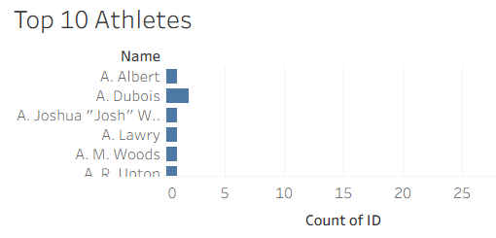
Figure 9: Top 10 Athletes: visible portion of the chart
Limitation: the visible names are in alphabetical order and the bars are very short (about one to two on the axis). The screenshot therefore does not show a ranked list of leading athletes, and no conclusion about top-performing athletes can be drawn from it. The author should confirm that a descending sort and a Top 10 filter have been applied, and supply an updated screenshot.

5. Dashboard
Two dashboard screenshots were supplied. Together they contain all nine views described in Section 4.
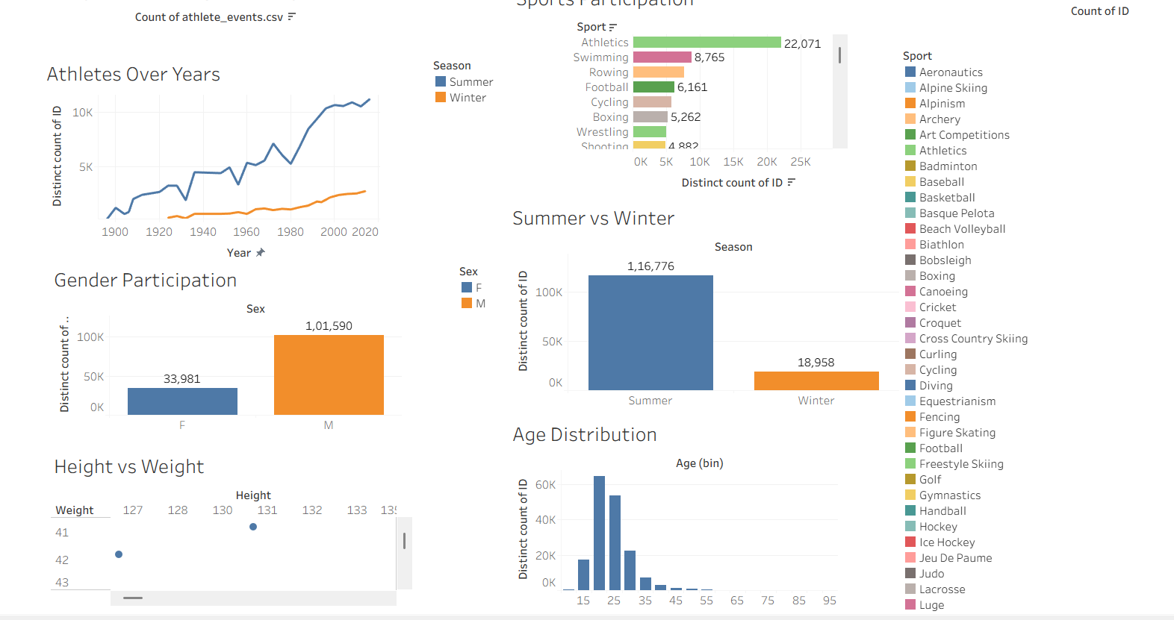
Figure 10: Dashboard view showing six views (Athletes Over Years, Gender Participation, Height vs Weight, Sports Participation, Summer vs Winter, Age Distribution)
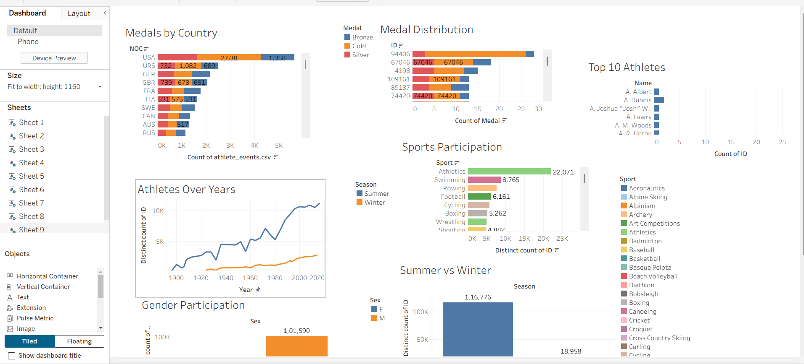
Figure 11: Dashboard authoring view in Tableau showing Medals by Country, Medal Distribution, Top 10 Athletes, Sports Participation, Athletes Over Years, Gender Participation and Summer vs Winter

5.1 Composition and Layout
- First screenshot: the left column holds Athletes Over Years, Gender Participation and Height vs Weight; the right column holds Sports Participation, Summer vs Winter and Age Distribution. Colour legends for Season, Sex and Sport are displayed beside the charts.
- Second screenshot: this is the dashboard authoring screen in Tableau. The top area holds Medals by Country, Medal Distribution and Top 10 Athletes, and the lower area holds Athletes Over Years, Sports Participation, Gender Participation and Summer vs Winter, with legends for Medal, Season, Sex and Sport. The Athletes Over Years chart is outlined as the selected item.
- Settings visible in the authoring pane: the Dashboard tab with the “Default” device layout (a “Phone” layout is also listed); Size shown as “Fit to width: height: 1160”; nine sheets listed as Sheet 1 to Sheet 9; layout objects such as Horizontal Container, Vertical Container, Text, Extension, Pulse Metric and Image; the Tiled option selected; and the “Show dashboard title” box unchecked.
It cannot be confirmed from the screenshots whether the two images show two separate dashboards or two states of one dashboard. The dashboard name and title are also not visible. Please confirm both.

5.2 Functionality
The following features are visible in the screenshots: value labels on bars; colour legends; sort indicator icons next to some field names; and scroll bars on the Sports Participation, Medals by Country, Medal Distribution and Height vs Weight views. Dashboard actions such as filtering by selecting a chart, highlighting or tooltips are not shown in the screenshots, so this report does not claim them. If such actions were configured, the author should add screenshots as evidence.

5.3 Design Observations
- Each view has a clear descriptive title, and axes are labelled with the measure used.
- Colour is used consistently for Season, Sex and Medal, with legends supplied.
- The Sport legend is very long and takes up considerable space; the legend adds little because the bars are already labelled with sport names.
- Several charts are cut off or require scrolling (Sports Participation, Height vs Weight, Medals by Country), which limits what can be seen at once.

6. Story
No screenshots or details of a Tableau Story were supplied. The scenes, captions and navigation of the Story therefore cannot be documented and are left blank for the author. Table 3 gives a proposed outline based only on observations that are visible in the screenshots; it is a suggestion and not a description of completed work.
Table 3: Proposed Story outline (to be replaced by the actual scenes and captions)
Scene | Proposed caption | View to show
1 | Olympic participation and medals at a glance | Dashboard
2 | The number of athletes has grown over time, mainly in Summer Games | Athletes Over Years
3 | Athletics attracts the most athletes of any sport | Sports Participation
4 | Men outnumber women, and Summer outnumbers Winter | Gender Participation; Summer vs Winter
5 | A small group of countries dominates the medal records | Medals by Country

6.1 Key Observations from the Visualizations
- Summer participation is larger than Winter participation throughout, and the Summer line rises to just above 10K athletes near the end of the axis.
- Athletics has the most athletes (22,071), followed by Swimming (8,765).
- There are about three male athletes for every female athlete (101,590 and 33,981).
- Summer accounts for about 86% of athletes and Winter about 14% (derived).
- Most athletes are in their twenties; very few are older than about 55.
- USA has the longest bar in Medals by Country, with 2,638 gold and 1,358 bronze records labelled.

7. Performance Testing
No performance test records, timings or testing screenshots were supplied. This report therefore makes no claim about loading times or test results. The table below lists the template factors, what can be stated from the screenshots, and what remains for the author to complete.
Table 4: Performance factors
Factor | Result
Amount of data rendered | To be confirmed (number of rows in athlete_events.csv is not visible)
Utilization of filters | To be confirmed. Sort icons are visible; no filter controls or dashboard actions are visible
Number of calculation fields | To be confirmed (none are visible in the screenshots)
Number of visualizations | 9 views (Sheet 1 to Sheet 9) and at least 1 dashboard; Story not evidenced
Slowest item

7.1 Data Consistency Check (from visible values)
One validation can be made from the screenshots. The Gender Participation chart totals 135,571 distinct athlete IDs (33,981 + 101,590), and the Summer vs Winter chart totals 135,734 (116,776 + 18,958). The difference is 163. A likely explanation, which is an interpretation and not verified, is that athletes who competed in both seasons are counted once in each season but only once in the sex chart.

8. Web Integration with Flask
No evidence of web integration (for example a Flask application or embedded Tableau views) was supplied for this project. This section is retained to match the reference structure and is intentionally left blank.
Item | Details
Framework / template used
Pages or routes created
Local address tested
Screenshot of embedded view

9. Publishing and Project Links
No publishing information or links were supplied. The fields below are left blank to be completed by the author.
Item | Link
Tableau Public workbook
GitHub repository
Demo video

10. Conclusion and Learnings

10.1 Conclusion
The project transformed Olympic athlete records from athlete_events.csv into nine Tableau views and a dashboard. The views show that athlete participation has grown over the period covered, that Summer participation is far larger than Winter participation, that Athletics is the sport with the most athletes, that male athletes outnumber female athletes by about three to one, and that most athletes are in their twenties. The Medals by Country chart shows the USA at the top of the ten countries displayed, ahead of URS, GER and GBR.

10.2 What Was Learned
Based on the work shown in the screenshots, the project involved:
- Building line, bar, scatter, binned column and stacked bar charts in Tableau.
- Using Distinct count of ID to count unique athletes, and binning a numeric field (Age).
- Using colour legends, value labels and sorting to make charts readable.
- Assembling several views into one dashboard.

10.3 Limitations
- The Height vs Weight chart is only partly visible, so no relationship can be reported.
- The Top 10 Athletes chart does not show a ranked list in the screenshot.
- The Medal Distribution chart shows identifiers and some labels display IDs instead of counts.
- Countries are shown as NOC codes only, and the medal measure counts file records.
- The Story, performance testing, web integration and publishing links are not evidenced.

10.4 Future Enhancements (proposed)
- Complete and document the Tableau Story with captions.
- Add dashboard actions (filtering by country, sport or season) and document them with screenshots.
- Correct the Top 10 Athletes sort and filter, and fix the labels in Medal Distribution.
- Use conventional gold, silver and bronze colours and show full country names.
- Add a medals-over-time view and a filter for Season and Year.

Appendix A: Items for the Author to Confirm
No. | Item
1 | Source, number of rows and columns, and download date of athlete_events.csv; a Data Source page screenshot if required.
2 | Whether the two dashboard screenshots show one dashboard or two, and the dashboard name.
3 | Which sheet number (Sheet 1 to Sheet 9) corresponds to each view.
4 | Whether dashboard actions (filtering, highlighting) or tooltips are configured.
5 | How records without medals were handled, and whether any filters or calculated fields were used.
6 | A full screenshot of Height vs Weight and a corrected Top 10 Athletes chart.
7 | Tableau Story screenshots, scene names and captions.
8 | Performance testing results, if testing was done.
9 | Web integration details and publishing links, if applicable.
10 | Team ID and Maximum Marks (both left blank as instructed).

